“A Confidence-Driven Probabilistic Machine Learning Framework for Electricity Demand–Supply Gap Forecasting and RAG-Based Energy Planning”

Dr.Kamatchi K.S
Associate Professor
Department of InformationTechnology
Sathyabama Institute of Science and Technology.Chennai kamatchi.k.s.it@sathyabama.ac.in

Udayakumar S
UG scholar
Department of Information Technology Sathyabama Institute of Science and Technology.Chennai
udhayakumar0101@gmail.com

Tamilarasu D
UG scholar
Department of Information Technology Sathyabama Institute of Science and Technology.Chennai tamilhackerd@gmail.com

Abstract— This study addresses the research gap in electricity demand and supply forecasting. Most of the existing papers and studies cover only the electricity demand forecasting or energy generation forecasting. This study proposes a Confidence-Driven Probabilistic Machine Learning Framework for Electricity Demand–Supply Gap Analysis and RAG-Based Energy Planning for Tamil Nadu, India. In our project The framework analyzes past electricity demand, power generation from different energy sources, and weather conditions to forecast the electricity demand and supply for the next three months and we getting the historical data’s and source-wise electricity. The sources are (coal, thermal, hydro, solar, wind and other sources), and we using weather parameters such as temperature, humidity, rainfall and solar irradiance. We going to develop separate machine learning models for electricity demand and electricity supply. The Machine learning models are Random Forest, XGBoost, LightGBM, LSTM. Different forecasting techniques are implemented and assessed using standard evaluation metrics such as MAE, RMSE, and MAPE. The algorithm that demonstrates the best predictive performance is chosen as the final forecasting model. To make the forecasts more accurate and reliable, confidence intervals are used to measure the uncertainty in the predictions. The calculated prediction intervals at 90%, 95%, and 99% confidence levels forecasts. The forecasted electricity demand and supply are compared to identify possible shortages or excess power. A Retrieval-Augmented Generation (RAG) module is also used to provide useful energy planning recommendations based on energy policies and existing knowledge. This framework helps improve forecasting, supports better planning, and promotes efficient use of electricity.
Keywords— Machine Learning, Demand–Supply Gap Analysis, Electricity Forecasting, Confidence Intervals, RAG, Energy Planning.

Introduction
Electricity is one of the most important things in our day to day life for industrial developments, our houses and modern life. Nowadays the demand of electricity is increasing due to the increasing number of electric vehicles, increasing digital infrastructure etc. in the world. It will help to lower the green house gas emissions whenever the electricity demand also rises in the same time when renewable energy sources like solar/wind are being fast integrated into the power systems to access carbon neutrality. The renewable energy generation's environmental benefits are very weather-dependent. The changes have made the operation of the power system more difficult, balancing of the grid, long-term energy planning. We need to make the forecasting accurate the electricity demand and supply will ensure it have stable grid operation. Over the years, the electricity demand forecasting has been enhanced from the old traditional statistical and autoregressive approach to the newer machine learning and deep learning approaches. Energy suppy integration and changing electricity[1] are added to the changed relationships. Further, some meteorological elements like temperature, humidity and seasonality are identified as significant factors of electricity demand. Some studies have demonstrated that assimilation of the weather information can improve the weather forecast in extreme weather and when electricity demand is high[1], [6].
In addition to electricity demand forecasting, energy generation forecasting model is also important because the output of renewable sources such as solar and wind depends on weather conditions and they produce electricity only when natural resources are available. Effective energy forecasting supports reliable power system operation. It helps to power system operators to reduce unused energy, improve energy storage planning, and support grid stability [2]. While various machine learning and deep learning models have been developed that give high accuracy of forecasting, most of the existing approaches are deterministic, offering only one prediction. Such forecasts do not reflect the degree of reliability of the forecast or uncertainty in the forecast. To bypass this limitation, probabilistic forecasting methods have been developed to provide a range of potential future values rather than just a single forecast [3]. These approaches yield prediction intervals and confidence intervals that can help to measure the uncertainty in the forecast and facilitate better planning for operations. More recently, there have also been important advances in using Transformer-based probabilistic models and Monte Carlo Dropout techniques to improve the reliability of the forecasts, while providing predictions with confidence scores that capture the uncertainty in real-world data [3]–[5].
Even though electricity forecasting has improved a lot, most existing studies don't offer a complete solution. Some research focuses only on forecasting electricity demand, while other studies look only at renewable energy generation [1], [2]. Similarly, probabilistic forecasting and confidence interval prediction are usually studied on their own, without combining demand and supply forecasting into a single model [3]-[5]. A few studies have looked at long-term energy demand-supply balance for future planning, but most of these rely on scenario analysis rather than machine learning models that can also estimate uncertainty [7].
Retrieval-Augmented Generation (RAG) is a newer technique that has shown promise in making Large Language Models (LLMs) more accurate. So far, RAG has been applied successfully to power system question-answering tasks [8]-[10], improving factual accuracy and reducing hallucinations. However, these approaches mainly focus on bringing knowledge and recommendations into the decision-making process, without addressing how forecast results themselves can be integrated into the planning process.
Based on the existing literature, there is still no integrated framework that can forecast electricity demand and electricity supply at the same time, while also quantifying forecasting uncertainty and supporting intelligent energy planning. Most previous studies handle these tasks separately, which limits their practical use for comprehensive power system planning. To address this gap, this study proposes a Confidence-Driven Probabilistic Machine Learning Framework for Electricity Demand–Supply Gap Forecasting and RAG-Based Energy Planning.
The proposed framework uses historical electricity and weather data to forecast future electricity demand and electricity supply, estimates the gap between them, and quantifies prediction uncertainty through confidence intervals at multiple confidence levels. In addition, a Retrieval-Augmented Generation (RAG) module combines these forecasting results with trusted energy-domain knowledge to generate reliable and explainable recommendations for energy planning. By bringing together forecasting, uncertainty estimation, demand–supply gap analysis, and knowledge-based decision support into one framework, this approach aims to offer a more practical solution for future power system planning and operation.
II Literature Survey
A. Electricity Demand Forecasting
Getting power demand forecasts right matters. It's what keeps generation schedules aligned, lets planners anticipate what's coming, and maintains that balance between supply and demand. The early approaches were straightforward—statisticians turned to ARIMA models, basic regression, support vector machines. They were fast to implement and easy to understand. The problem? Real electricity demand doesn't follow a clean pattern. It swings around, carries trends, holds onto patterns for weeks at a time. Those older statistical methods just weren't built to catch all of that complexity, so as grids got more complicated, accuracy suffered [7], [8].
That's where machine learning and deep learning stepped in. Researchers figured out that breaking demand signals into pieces—separating the noise from the actual trend—then letting a model learn each part independently worked better. The ECEEMDAN-BiGRU model does exactly that, and it actually produces forecasts useful enough for real energy planning [9]. Then came Transformers. These models turned out to be really good at picking up patterns that stretch out over long time horizons—way better than the older recurrent networks. TPEDF combines a Transformer with probabilistic modeling, so you get not just a demand forecast but also a sense of how confident you should be about it [10]. PMS-EDF pushes it further, learning patterns at multiple time scales simultaneously and adjusting uncertainty estimates as conditions change [11].
Weather matters—a lot. When researchers started feeding temperature, humidity, and rainfall data into LSTM and Transformer models, accuracy jumped noticeably compared to models that only looked at past demand patterns. The improvement was especially clear during unexpected spikes or drops [12], [13]. But here's where it gets interesting: for all the progress in deep learning and weather integration, almost everything still focuses on demand alone. Nobody's really combining demand forecasts with energy supply forecasts in the same framework, figuring out where the two might diverge, or actually producing confidence intervals that could guide real planning decisions.
B. Energy Supply Forecasting
Energy supply forecasting is a different beast. Solar and wind don't run on demand—they run on whatever the weather decides to throw at them. That unpredictability matters enormously when you're trying to schedule generation, manage storage, or keep the grid stable [14], [15].
LSTM models work well here because they're good at catching patterns that unfold over time. When you feed them weather data—solar irradiance, wind speed, temperature—they get noticeably better at predicting output, which helps with planning and cuts down on wasted generation [14]. Some researchers took this further with AutoML frameworks that basically handle feature selection and model tuning on their own, adapting automatically across different weather scenarios [15].
Recent work is tackling the spatial side too—the fact that generation varies across geography. Graph Neural Networks paired with LSTM models can learn how solar stations in different locations relate to each other, then forecast regional output more accurately than simpler methods [16]. Others have figured out how to compress massive weather prediction data into digestible spatial features. This approach improves both regular point forecasts and probabilistic ones while keeping computational costs down [17].
Extreme weather is its own problem. When conditions get harsh, models that pull together multiple weather sources with deep learning hold up better because they capture the messy, nonlinear ways weather actually affects generation [18], [19]. But here's the thing—most of this renewable work still looks at solar or wind in isolation. Nobody's really bringing energy forecasting together with demand forecasting in the same probabilistic framework. And nobody's actually forecasting the gap between what you need and what you'll have, across different confidence levels.
C. Probabilistic Forecasting and Confidence Interval Estimation
There's a real problem with just giving a single forecast number: grid operators don't know if they should trust it or how much room to leave for things going wrong. That's why probabilistic forecasting has become such a big deal—instead of one prediction, you get a range of likely outcomes with confidence intervals attached [20], [21].
TPEDF is a good example—it pairs a Transformer with probabilistic modeling, so instead of guessing a single demand number, you get the whole distribution of possible outcomes [20]. PMS-EDF does something similar but adds adaptive multi-scale learning, which helps it capture patterns over longer stretches of time while still handling uncertainty correctly [21]. The same logic works for energy supply. When you forecast wind and solar with prediction intervals—a range instead of a flat number—scheduling and reserve allocation both improve, and it's easier to work weather-dependent sources into everyday grid operations [22], [23].
One Nature Communications paper really stood out to me. Instead of treating demand and supply as separate problems, it built a framework that forecasts both together using shared probability distributions and freely available weather data. What they found was that this joint approach actually beat the standard deterministic methods, and it let operators allocate reserves more intelligently [24]. There are methods for confidence intervals too—quantile regression, Bayesian models, Monte Carlo sampling—all ways of drawing bounds around your forecast so operators know what to trust [25], [26].
Here's where the gap shows up: most probabilistic work still only tackles one side—either demand or supply, not both. Joint forecasting of the actual gap between them across different confidence levels? Practically doesn't exist. And almost nothing connects those forecasts to systems that could actually help operators make planning decisions.
D. Demand–Supply Gap Forecasting and RAG-Based Energy Planning
This should be obvious: power systems stay stable when demand and supply stay matched. You'd think forecasting them together would be the natural focus—yet most research still splits them apart [27], [28].
There are a few exceptions worth noting. One day-ahead framework brought demand and energy generation together under shared probability distributions, and the results were clearly better—more accurate forecasts, smarter reserve allocation, real advantages over deterministic approaches [24]. Another approach folded probabilistic supply forecasting into combined heat and power dispatch, which improved flexibility and renewable output utilization [22]. But neither of these goes the extra step of actually forecasting the gap between what you need and what you'll have.
There's another line of research running parallel to all this forecasting work. It's about how power systems handle knowledge and get decision support, and it centers on Large Language Models paired with Retrieval-Augmented Generation (RAG). The basic idea: LLMs on their own tend to make things up—RAG fixes that by pulling actual information from a real knowledge base before answering, so the answer is grounded in facts rather than just inference. ChatGrid shows this in action for energy dispatch—it gives operators technically sound answers backed by actual retrieved information [29]. Other researchers have built similar energy knowledge systems aiming for the same thing: fewer factual slip-ups, better understanding of context [30].
RAG keeps getting more sophisticated. Some systems now pull documents apart adaptively and retrieve information in multiple passes instead of just once, which sharpens accuracy for grid-specific questions [31]. Others bring in multiple specialized models that cross-check each other before settling on an answer [32], and some have fine-tuned RAG specifically around power dispatch regulations [33].
Here's the gap: one research thread is great at forecasting, the other is great at retrieving knowledge and reasoning over it—but nobody connects them. Nobody takes those probabilistic demand and supply forecasts, figures out the gap between them, and then feeds that into a RAG system that could actually advise an operator on what to do. Right now, forecasting models just spit out numbers and stop. They don't say what you should actually do about those numbers. This study is trying to fill that hole by bringing probabilistic demand–supply gap forecasting, confidence intervals, and RAG-based planning advice all together into one framework [24], [29]–[33].
III Methodology
3.1 Data Collection
The datasets used in this study were collected from reliable government organizations and publicly available data sources. Historical electricity demand data and electricity generation data, including coal, oil and gas, nuclear, hydro, solar, wind, small hydro, and bio-power generation, were collected from the Central Electricity Authority (CEA) and Grid India (formerly POSOCO). Weather-related data, including temperature, humidity, and solar irradiance, were obtained from NASA POWER, while rainfall data was collected from the India Meteorological Department (IMD). The data was obtained from multiple sources, resulting in datasets with different formats and different time ranges. Therefore, all datasets were carefully reviewed before preprocessing and integration. The final dataset consists of monthly records of 129 from April 2015 to December 2025, which were used for electricity demand forecasting, electricity supply forecasting, demand–supply gap analysis, and RAG-based energy planning.
Dataset | Source
Electricity Demand | NITI Aayog
Electricity Supply | NITI Aayog
Temperature | NASA
Humidity and Rainfall | NASA
Solar Irradiance | National Water Data Portal
3.2 Data Preprocessing and Feature Engineering
After collecting the datasets, preprocessing was performed to prepare the data for machine learning. Missing values, duplicate records, and incorrect date formats were identified and corrected. The hourly solar irradiance data was converted into daily averages and then into monthly averages so that it matched the monthly format of the other datasets. All datasets were then merged using the Date column to create one final dataset. Additional features such as Year and Month were extracted from the Date column to help the models learn seasonal patterns. Finally, the dataset was divided into training data and testing data using a time-based split to maintain the chronological order of the data.
3.3 Electricity Demand Forecasting
To forecast future electricity demand, four machine learning models were developed: Random Forest, XGBoost, LightGBM, and Long Short-Term Memory (LSTM). Each model was trained using the historical demand dataset and tested using the testing dataset. The performance of the models was evaluated using Mean Absolute Error (MAE), Root Mean Square Error (RMSE), Mean Absolute Percentage Error (MAPE), and R² score. The Random Forest model achieved an R² score of 0.31, the XGBoost model achieved 0.34, the LightGBM model achieved 0.29, and the LSTM model achieved 0.78. Among these models, the LSTM model produced the best results and was selected as the final model for electricity demand forecasting.
3.4 Electricity Supply Forecasting
The same four machine learning models were also used to forecast future electricity supply. The models were trained using historical electricity generation data and evaluated using the same performance metrics. The Random Forest model achieved an R² score of 0.31, the XGBoost model achieved 0.31, the LightGBM model achieved 0.38, and the LSTM model achieved 0.56. The LSTM model showed the highest prediction accuracy with the lowest error values. Therefore, it was selected as the final model for electricity supply forecasting.
3.5 Prediction Interval Estimation
After selecting the best forecasting model, prediction intervals were generated to measure the uncertainty in the predictions. Instead of predicting only one future value, the model also produced 90%, 95%, and 99% prediction intervals Prediction intervals were estimated using the distribution of forecasting residuals to quantify uncertainty around the point forecasts. The residual-based uncertainty was used to construct lower and upper prediction bounds at 90%, 95%, and 99% confidence levels for both electricity demand and supply.
3.6 Demand–Supply Gap Analysis
Month | Predicted Gap-MU | 95% PI | Status
Jan 2026 | 2237.88 | [138.99,4336.77] | Shortage
Feb 2026 | 3078.30 | [979.41,5177.19] | Shortage
Mar 2026 | 3020.25 | [921.36,5119.14] | Shortage
Positive gaps indicate shortages, with 95% intervals quantifying forecast uncertainty.
3.7 RAG-Based Energy Planning Framework
After forecasting and demand–supply gap analysis, the results were passed to the Retrieval-Augmented Generation (RAG) framework to generate intelligent energy planning recommendations. The predicted gap was classified into three impact levels: gaps below 3000 MU were considered low impact, gaps between 3000 and 4500 MU were classified as moderate impact, and gaps above 4500 MU were considered high impact.
The generated query was converted into vector embeddings using an embedding model. At the same time, energy-related documents such as electricity policies, energy reports, government planning documents, and research papers were also converted into embeddings and stored in a FAISS vector database. The vector database searched for documents that were most similar to the forecasting query and retrieved the most relevant information.
The retrieved documents and the forecasting results were then provided as input to a Large Language Model (LLM). The LLM used both the forecasting results and the retrieved knowledge to generate meaningful recommendations instead of relying only on its built-in knowledge. Based on the predicted electricity conditions, the system generated practical suggestions such as increasing energy generation, purchasing additional electricity, reducing peak demand through demand response programs, scheduling maintenance during low-demand periods, and promoting energy conservation measures. By combining machine learning forecasting with the RAG framework, the proposed system not only predicts future electricity demand and supply but also provides useful recommendations that support better energy planning and decision-making.

IV. Results and Discussion
4.1 Experimental Setup
The suggested framework was developed in Python 3.12 with the help of Jupyter Notebook. Pandas and NumPy were used for data preprocessing and analysis. The forecasting models: Random Forest, XGBoost, LightGBM, and LSTM were developed using the Scikit-learn, XGBoost, LightGBM, and TensorFlow/Keras libraries. The data was split into 80% training data and 20% testing data, with a time-based split to ensure the data's chronological order. Four performance metrics including Mean Absolute Error (MAE), Root Mean Square Error (RMSE), Mean Absolute Percentage Error (MAPE) and Coefficient of Determination (R²) were used to assess the performance of each forecasting model. The most successful model was obtained and prediction intervals were created, with the forecasting outcomes combined within the Retrieval-Augmented Generation (RAG) system to generate energy planning recommendations.
4.2 Electricity Demand Forecasting Results
Model | MAE | RMSE | MAPE (%) | R² Score
Random Forest | 741.63 | 909.69 | 6.56 | 0.31
XGBoost | 619.18 | 724.51 | 5.56 | 0.34
LightGBM | 634.18 | 748.24 | 5.66 | 0.29
LSTM | 368.72 | 412.93 | 3.41 | 0.78
Figure 1: Electricity Demand Forecasting Results
The performance of the four machine learning models that were used for electricity demand forecasting is presented in Table 2. Models were tested using Mean Absolute Error (MAE), Root Mean Square Error (RMSE), Mean Absolute Percentage Error (MAPE) and R2 score. LSTM showed the best performance in terms of R² score and error values among all the models, which is the best model for predicting future electricity demand. Thus, LSTM is chosen for future steps of the proposed framework.
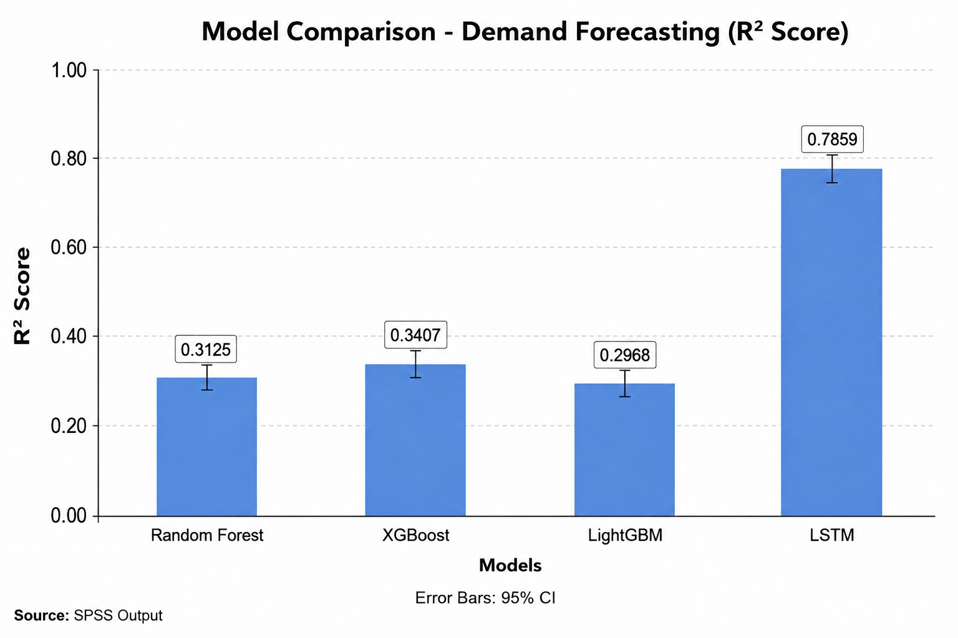
4.3 Electricity Supply Forecasting Results
Model | MAE | RMSE | MAPE (%) | R² Score
Random Forest | 823.30 | 1220.9 | 6.89 | 0.31
XGBoost | 847.76 | 1215.3 | 7.13 | 0.31
LightGBM | 802.74 | 1157.4 | 6.74 | 0.38
LSTM | 731.56 | 973.93 | 6.30 | 0.56
Figure 2: Electricity Supply Forecasting Results
A comparison of the performance of the four machine learning models for electricity supply forecasting is shown in Table 3. The performance metrics of the models were the same: Mean Absolute Error (MAE), Root Mean Square Error (RMSE), Mean Absolute Percentage Error (MAPE) and R2 score. The results reveal LSTM was able to secure the highest R² score and the lowest prediction error, thereby performing the best. Based on this, LSTM was chosen as the final model to forecast electricity supply.
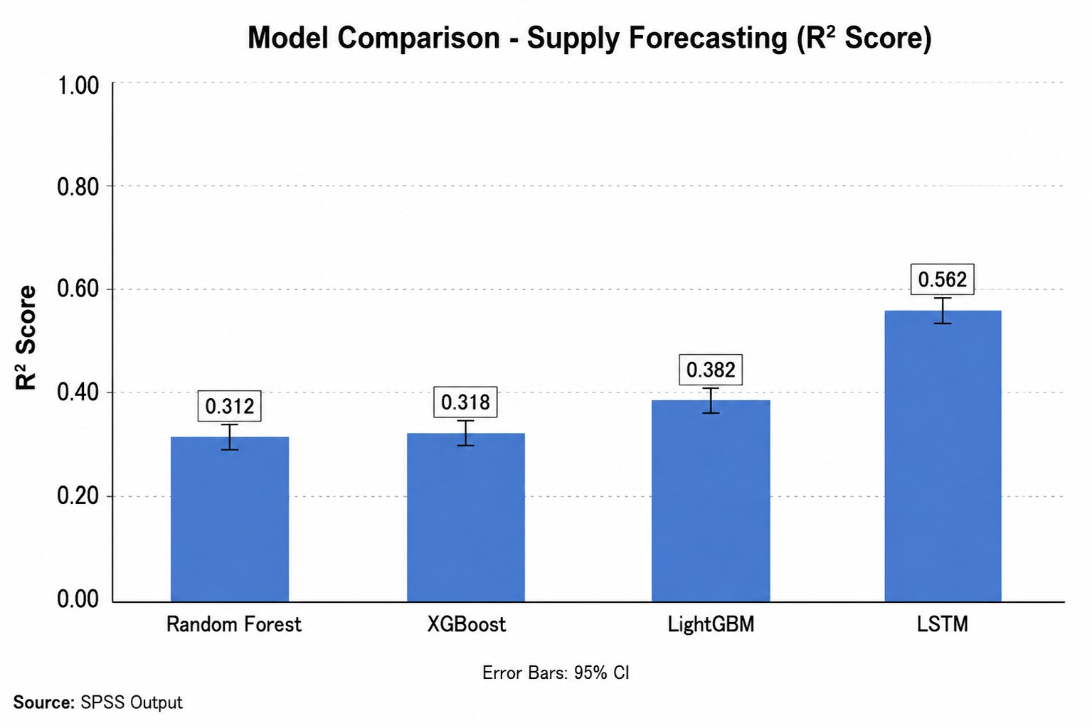
V. Conclusion
This research developed a machine learning framework to forecast electricity demand and supply across Tamil Nadu by analyzing historical electricity data and weather patterns. To identify the most accurate model, the team compared four different approaches—Random Forest, XGBoost, LightGBM, and LSTM. They then calculated prediction intervals at 90%, 95%, and 99% confidence levels to account for uncertainty in future forecasts. Beyond just predicting numbers, the study also examined the demand-supply gap to identify potential electricity shortages and surpluses. The results showed that this framework delivers reliable forecasts that can directly support electricity planning and resource management decisions. To make the forecasting system even more useful, the team integrated a Retrieval-Augmented Generation (RAG) framework. This addition allows the system to pull relevant information from an energy knowledge base and generate actionable recommendations for future energy planning. Together, these components—machine learning forecasting, uncertainty estimates, gap analysis, and AI-powered recommendations—create a comprehensive decision support system for managing electricity resources. While this work shows promising results, there's room to expand it further. Adding real-time electricity data, incorporating more weather variables, and exploring advanced deep learning techniques like transformers could push the forecasting accuracy even higher and lead to better-informed energy planning decisions.
VI. References
[1] Shivam Sharma, Anamika Goel, Vedang Tiwari and Shiv Pratap Singh Waghel, "Electricity Demand Forecasting: A Review of Statistical, Machine Learning, Deep Learning and Hybrid Approaches,"DOI:10.1109/ACET67282.2025.11430367.
[2] Stephen J. Lee and Cailinn Drouin,"Forecasting Residential Heating and Electricity Demand with Scalable, High-Resolution, Open-Source Models," DOI: 10.1016/j.egyai.2026.100726.
[3] Anber Abraheem Shlash Mohammad, Badrea Al Oraini, Suleiman Ibrahim Mohammad, Sultan Alaswad Alenazi, Torki M. Al-Fawwaz and Asokan Vasudevan, "Mathematical and Statistical Modelling of Electricity Demand Forecasting Using Artificial Neural Networks and SARIMA: Implications for Energy Supply Chain Planning," DOI: 10.1016/j.aej.2026.01.046.
[4] Bo Jie, Jumpei Baba and Akiko Kumada, "Mathematical Analysis of Time-series & Meteorological Factors in Electricity Demand Forecasting Based on Carbon Neutrality," DOI: 10.1109/ICPSASIA58343.2023.10294862.
[5] Sylvester William Chisale, Han Soo Lee and Manuel Alejandro Soto Calvo, "Strategic Forecasting of Electricity Demand for 100% Electrification in Malawi by 2063: A Data-Driven ECEEMDAN-BiGRU and Quantile Regression Approach," DOI: 10.1016/j.energy.2025.137212.
[6] Difei Miyao and Masaki Nakamura, "Time and Day-Based Peak Electricity Demand Forecasting: A Comparative Analysis of Machine Learning Models for Peak Cut and Decarbonization," DOI: 10.1109/ICRERA62673.2024.10815184.
[7] Ligang Hou, Xin Shen and Liqi Zhang, "Urban Electricity Demand Forecasting with a Hybrid Machine Learning Model,"DOI: 10.1109/ICNSC58704.2023.10319027.
[8] Zhanxing Xu, Lingjun Xu, Zhanzhi Liu and Qiang Liu, "Analysis of Pumped Storage Hydropower Demand-Supply Gap in East China," DOI: 10.1109/ICCEPE66357.2025.11193283.
[9] Jiaxi Li, Ming Wen, Bo Wen, Zongchao Yu, Yue Qin and Xinyang Zhang, "Multi-objective Optimization of Power Supply and Demand Balance Considering the Impact of Coal Prices on Coal-Fired Power Generation Willingness," DOI: 10.1109/EI264398.2024.10990690.
[10] Wang Lening, Sun Dagen, Li Dong, Yang Chaoran, Duan Hengcheng, Li Jiao and He Zhonghai, "Electricity Demand Forecasting via Multi-Scale Structure-Guided Transformer with Adaptive Paths," DOI: 10.1109/ICCWAMTIP64812.2024.10873637.
[11] Feng Xu, Yi Lu, Peng Qiu and Chao Ding,"Flexible Combined Heat and Power Dispatch Based on Probabilistic Prediction of Wind Power," DOI: 10.1109/AEEES56888.2023.10114217.
[12] Behrouz Banitalebi, Srimantoorao S. Appadoo, Yuvraj Gajpal and Aerambamoorthy Thavaneswaran, "Intelligent Probabilistic Forecasts of Day-Ahead Electricity Prices in a Highly Volatile Power Market," DOI: 10.1109/COMPSAC51774.2021.00034.
[13] Guillermo Terrén-Serrano, Ranjit Deshmukh and Manel Martínez-Ramón,"Probabilistic Day-Ahead Forecasting of System-Level Renewable Energy and Electricity Demand," DOI: 10.1038/s41467-026-69015-w.
[14] Haisheng Hong, Zhixuan Zhao, Zhifang Zhu, Zheng Sun, Shengkai Chen and Zihao Weng, "Probabilistic Analysis Enabled Proactive Fault Risk Assessment of Electricity Power Distribution Systems," DOI: 10.1109/PEEEC63877.2024.00013.
[15] Yang Cao, Zhenzhen Dang, Feng Wu, Xovee Xu and Fan Zhou, "Probabilistic Electricity Demand Forecasting with Transformer-Guided State Space Model," DOI: 10.1109/AUTEEE56487.2022.9994294.
[16] Mingjian Ni, Jing Zhang, Cong Fu, Jiaqi Wang, Xin Ning and Siyuan Li, "ChatGrid: Intelligent Knowledge Q&A for Power Dispatching Control Based on Large Language Models and Retrieval-augmented Generation," DOI: 10.1109/ITNEC60942.2024.10733337.
[17] Rui Wang, Qingyu Wang, Yalin Nan, Hang Ye and Panbo He, "Construction and Evaluation of a Large Language Model for the Energy Domain Leveraging Retrieval-Augmented Generation," DOI: 10.1109/ICFTIC68075.2025.11324983.
[18] M. Harish, S. Suganth, S. Sritharan and R. Nithiavathy, "Generative AI Powered Chatbot for Energy Consumption Optimization Using Retrieval-Augmented Generation," DOI: 10.1109/ICISCN67954.2026.11566088.
[19] Shuai Zhao, Jun Feng, Xiaojun Shen, Huaguang Yan, Zhenyu Chen, Jianguang Du, Pengxin Luo and Zhen Wang, "Knowledge Retrieval Enhancement for Power System Based on Adaptive Dynamic Text Segmentation and Hierarchical Multi-Query," DOI: 10.1109/PSGEC66102.2025.11151081.
[20] Xin Huang, Yibo Chen, Xiaowen Feng, Hongyu Zhu and Chao Tang, "Multi-Agent Cooperative Retrieval-Augmented Generation for Efficient Electric Power Knowledge Retrieval Quiz," DOI: 10.1109/ICPEA67476.2025.11349299.
[21] Ying Zou, Ying Liu, Sai Zhang, Bochuan Song and Xiao Liang, "Robust Fine-Tuning of Large Language Models for Retrieval Augmented Generation in Power Grid Dispatching Regulations," DOI: 10.1109/POWERCON66300.2025.11295460.
[22] Jichao Ye, Linping Liu, Yonghai Xu, Tong Xia, Shiwang Yang and Xinwei Hu, "Distributed Photovoltaic Power Forecasting Based on Auto Machine Learning Framework and Fusion Perception Technology," DOI: 10.1109/ICGEPS65133.2025.11034521.
[23] Rui Zhang, Yanning Wang and Yujie Tang, "Enhancing Agent-Based Electricity Purchase Forecasting Accuracy Comprehensively Supports Power Supply and Electricity Spot Trading," DOI: 10.1109/ICEPET61938.2024.10625854.
[24] Cheng Jifeng, Sun Junjie, Wang Li, Wu Zhenghao, Wang Yuqing and Wang Fei, "Optimization Strategy for Ultra-short-term Photovoltaic Power Forecasting Based on the Fusion of Day-ahead Forecast and Intraday Real-time Information," DOI: 10.1109/IAS62731.2025.11061420.
[25] Shumin Sun, Shibo Wang, Yan Cheng, Liqun Sun, Xiaoqi Zhang and Yunhai Lv, "Photovoltaic Station Power Forecasting for Integrated Energy Systems Based on Spatiotemporal Features," DOI: 10.1109/CEEPE64987.2025.11034336.
[26] Hyeonwoo An, Guwon Yoon, Keonhee Cho, Yahui Dong, Seunghwan Kim and Sehyun Park, "Renewable Energy Generation Forecasting Model for Reducing Power System Load and Solving Output Control Issues," DOI: 10.1109/APACE62360.2024.10877341.
[27] Xiaoli Zhu, Xuannian Lei, Haiyi Xiao, Hang Xu and Zhiyuan Zhu, "Research on Multi-Scale Forecasting Model of Wind Power in Extreme Weather Based on Multi-Source Heterogeneous Data Fusion," DOI: 10.1109/AECSPE66597.2025.00036.
[28] Jia Sun, Zehui Wang, Xiaozhuo Guan, Pingjian Yang, Xuesong Qi, Zhenxin Li, Li Tian and Zhen Wu, "Research on Ultra-Short-Term Wind Power Generation Forecasting Based on Expert System Method and RBF Neural Network Prediction Model," DOI: 10.1109/ICESEP62218.2024.10651817.
[29] Sajib Debnath, Uzzal Basu, Md Abubakkar, Md Robiul Islam, Mithu Debnath and Ashis Kumer Biswas, "Extreme Weather Grid Load Forecasting using Weather-Informed LSTM and Transformer Machine Learning Models," DOI: 10.1109/NAPS66256.2025.11272315.
[30] Georgios Mitrentsis, "From High-Dimensional Weather Data to Accurate Renewable Generation Forecasts: A Statistical Aggregation Method," DOI: 10.1109/EEM68581.2026.11589794.
[31] Shani Abeywickrama and P. P. G. Dinesh Asanka,"Integrating Weather Patterns into Machine Learning Models for Improved Electricity Demand Forecasting in Sri Lanka," DOI: 10.1109/SCSE59836.2023.10215047.
[32] Indra A. Aditya and Didit Adytia, "Modelling of Spatially Correlated Weather-Based Electricity Forecasting Using Combined Frequency-Based Signal Decomposition with Optimized Boosting Approach," DOI: 10.1016/j.ijepes.2025.110698.
[33] Rishi Malyala, Abhijit Palakurthy, Anam Malik and Jayashri Ravishankar, "Confidence Interval Calibration for Transformer-GRU Forecasting Models using Monte Carlo Dropout," DOI: 10.1109/ETFG61999.2025.11402342.

